📌 1.3 SOAP vs REST (Detailed Comparison)

🔹 1️⃣ Protocol vs Architectural Style
🔵 SOAP = Protocol
- Strict rules
- Fixed message format
- Must follow defined standards
- Uses WSDL contract
👉 Think of SOAP like a strict law book.

🟢 REST = Architectural Style
- Flexible guidelines
- Uses standard HTTP
- No strict contract required
- Developer freedom
👉 Think of REST like best practices, not strict law.

🎯 Key Difference
SOAP | REST
Protocol (fixed standard) | Architectural style (guidelines)
Strict message structure | Flexible implementation

🔹 2️⃣ Data Format (XML vs JSON)

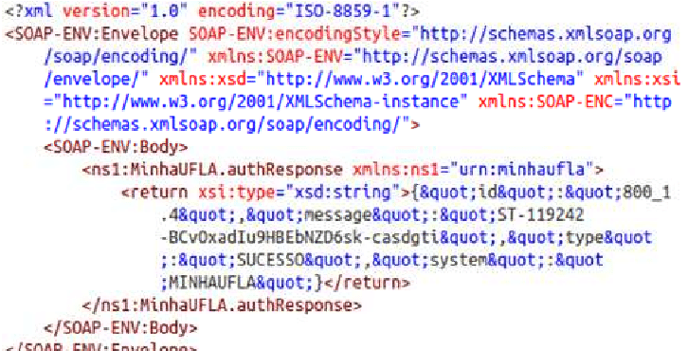
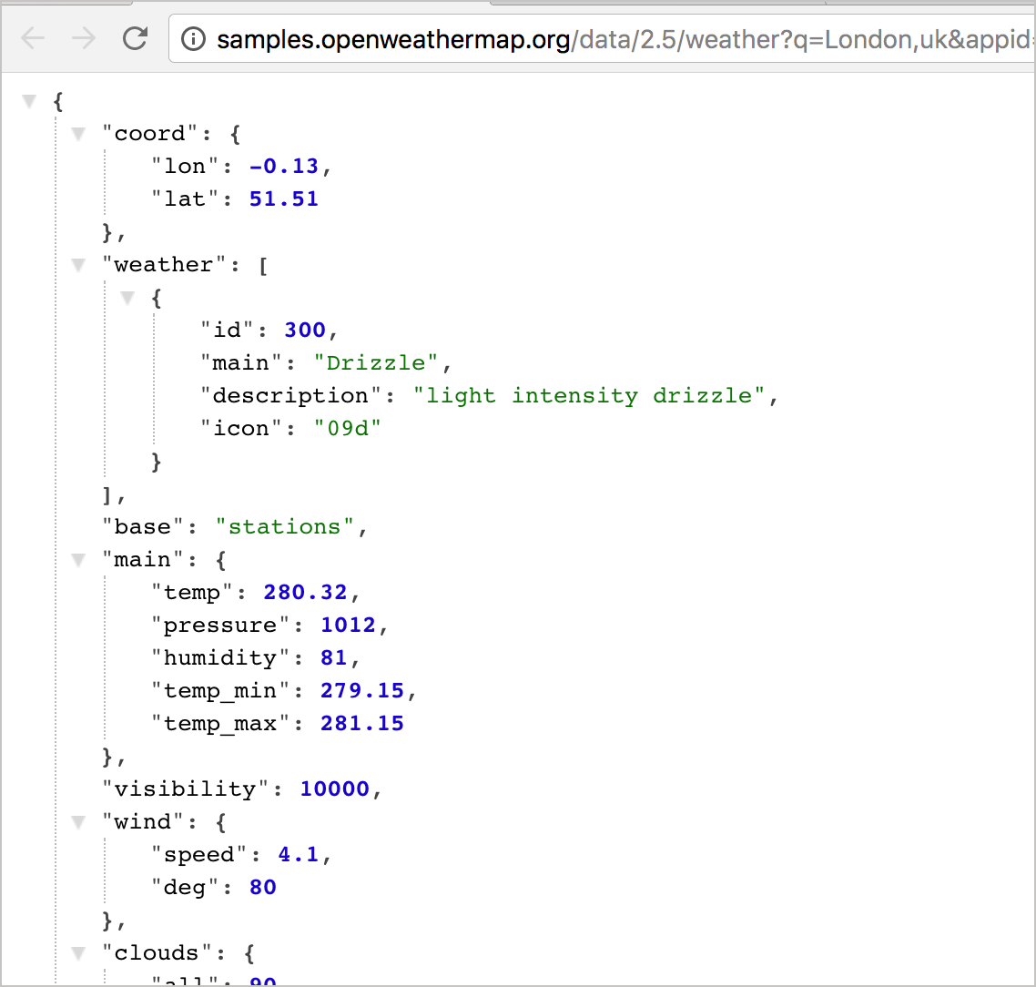
4
SOAP:
- Only XML
- Verbose
- Heavy structure
- Closing tags required
Example:
<user>
<name>Lakshay</name>
</user>

REST:
- Mostly JSON
- Lightweight
- Easy to parse
- Human-readable
Example:
{
"name": "Lakshay"
}

🎯 Why JSON Wins
- Less bandwidth
- Faster parsing
- Cleaner structure
- Better for mobile apps

🔹 3️⃣ Performance
SOAP:
- Slower
- Heavy XML parsing
- Large message size
- More CPU usage
REST:
- Faster
- Lightweight
- Low bandwidth usage
- Better caching

🎯 Interview Line:
REST performs better due to lightweight JSON format and reduced message overhead.

🔹 4️⃣ Security Standards
SOAP Security:
- WS-Security
- Built-in encryption
- Digital signatures
- Identity validation
- Message-level security

REST Security:
- HTTPS (Transport-level security)
- OAuth 2.0
- Bearer Tokens
- API Keys
- JWT

🔥 Important Difference
SOAP → Security inside message
REST → Security via HTTP & tokens

🔹 5️⃣ Statelessness
SOAP:
Can be:
- Stateless
- Stateful
It supports session-based operations.

REST:
Always Stateless
Each request must contain:
- Authentication info
- Required data
Server does NOT store client session.

🎯 Why Stateless is Powerful?
- Easier scaling
- No session memory
- Better distributed systems

🔹 6️⃣ Scalability
SOAP:
- Harder to scale
- Heavy messages
- Stateful possible
REST:
- Highly scalable
- Stateless
- Load balancing friendly
- Works great in microservices

🧠 Why REST Scales Better?
Because:
- No session storage
- Each request independent
- Easy horizontal scaling

🔹 7️⃣ Enterprise vs Web Applications Usage
SOAP Used In:
- Banking
- Insurance
- Government systems
- Enterprise integrations
- Legacy systems
Why?
- Strict contracts
- High security
- Reliable transactions

REST Used In:
- Web applications
- Mobile apps
- Microservices
- Public APIs (Google, Twitter, etc.)
Why?
- Fast
- Lightweight
- Easy integration

🧠 COMPLETE COMPARISON TABLE
Feature | SOAP | REST
Type | Protocol | Architectural Style
Format | Only XML | JSON, XML, etc.
Speed | Slower | Faster
Security | WS-Security | HTTPS + OAuth
Stateful | Yes (can be) | No (stateless)
Scalability | Limited | High
Usage | Enterprise | Web & Mobile

🎯 API Testing Perspective
As an API Tester:
If project is:
- Banking → High chance SOAP
- E-commerce / Mobile App → Almost always REST
In real industry today:
👉 80–90% APIs are REST

